# **DATABASE PROJECT:**

# **MOBILE PHONE STORE WEBSITE**

GROUP MEMBERS:

MURTAZA AHMED K213440

HAMZA AHMED K213344

# Proposal:

The project aims to replicate the mobile shopping experience, specifically tailored for a mobile phone store website featuring various brands. Users have the ability to register, log in, explore mobile phone categories, select specific items with preferences like model and color, and add them to their virtual cart. The user journey seamlessly continues as they input shipping details for delivery, concluding with the review of a comprehensive receipt summarizing their chosen mobile devices.

In addition to the user-centric features, the admin possesses the capability to efficiently manage users, overseeing their accounts and interactions. Furthermore, the admin can handle product management, ensuring the availability and organization of various mobile phone models and brands. Lastly, the admin has control over order management, facilitating oversight and coordination throughout the entire process, from user selection to product checkout and order fulfillment.  
  
**The functions that the project would include would be:**

**User Functions**

1.User Registration

2.User Login

3.Browse Mobile Phones

4.Select and Add to Cart

5.View and Manage Cart

6.Checkout and Provide Shipping Information

**Admin Functions:**1)Admin Login

2)Manage Users

3)Manage Mobile Phones

4)Manage Orders

5)Manage Categories

**Technologies Used:** Bootsrap,CSS, JavaScript, PHP, MySQL

Normalization:   
I have normalized my tables from 1NF to BCNF by ensuring that data is organized and dependencies are appropriately handled. In 1NF, I removed repeating groups and ensured atomic values. Moving to 2NF, I addressed partial dependencies by ensuring non-prime attributes are fully functionally dependent on the entire primary key. In 3NF, I eliminated transitive dependencies, and finally, in BCNF, I ensured that for every non-trivial functional dependency, the determinant is a superkey. This step-wise normalization process ensures data integrity and minimizes redundancy in the database.

user_id is transitively dependent on order_id through the orders table.

Create a new table (order_products).

Normalization Implementation Report:

In the pursuit of designing a robust and normalized database structure for the mobile store website, meticulous efforts were invested to ensure compliance with the principles of 1NF, 2NF, and 3NF across all tables. The following is a detailed examination of the normalization status for each table:

1. admin_info:

- 1NF and 2NF: The table conforms to 1NF and 2NF standards with well-organized attributes containing atomic values.

2. brands:

- 1NF and 2NF: Atomic values are maintained, adhering to 1NF and 2NF criteria without any multi-valued attributes.

3. cart:

- 1NF: The table ensures atomic values, meeting 1NF standards. Clarification is needed for the field id_add, which may impact 2NF considerations.

- 2NF: The combination (p_id, id_add, user_id) has been addressed for comprehensive normalization.

4. categories:

- 1NF and 2NF: The table is well-structured, ensuring atomic values without multi-valued attributes.

5. email_info:

- 1NF and 2NF: The table satisfies 1NF and 2NF standards with attributes containing atomic values.

6. logs:

- 1NF and 2NF: The table maintains atomic values, satisfying both 1NF and 2NF criteria.

7. orders:

- 1NF: The table adheres to 1NF standards with attributes containing atomic values.

- 2NF: Dependency considerations for p_status have been incorporated for 2NF adherence.

8. orders_info:

- 1NF and 2NF: The table complies with 1NF and 2NF standards.

- 3NF: The combination (f_name, email, address, city, state, zip) has been meticulously addressed for normalization.

9. order_products:

- 1NF and 2NF: The table is structured to have atomic values, meeting 1NF and 2NF criteria.

10. products:

- 1NF, 2NF, and 3NF: The table is meticulously designed without multi-valued attributes or repeating groups, satisfying 1NF, 2NF, and 3NF standards.

11. user_info:

- 1NF and 2NF: The table complies with 1NF and 2NF standards.

- 3NF: Detailed scrutiny for the combination (address1, address2) has been successfully completed.

12. user_info_backup:

- 1NF and 2NF: The table adheres to 1NF and 2NF standards.

- 3NF: Thorough examination for the combination (address2, address1) has been conclusively addressed.

This exhaustive normalization implementation report attests to the meticulous steps taken to ensure the mobile store website's database structure aligns seamlessly with 1NF, 2NF, and 3NF standards. Each table underwent systematic analysis, and adjustments were executed to foster an optimized and robust relational database design.

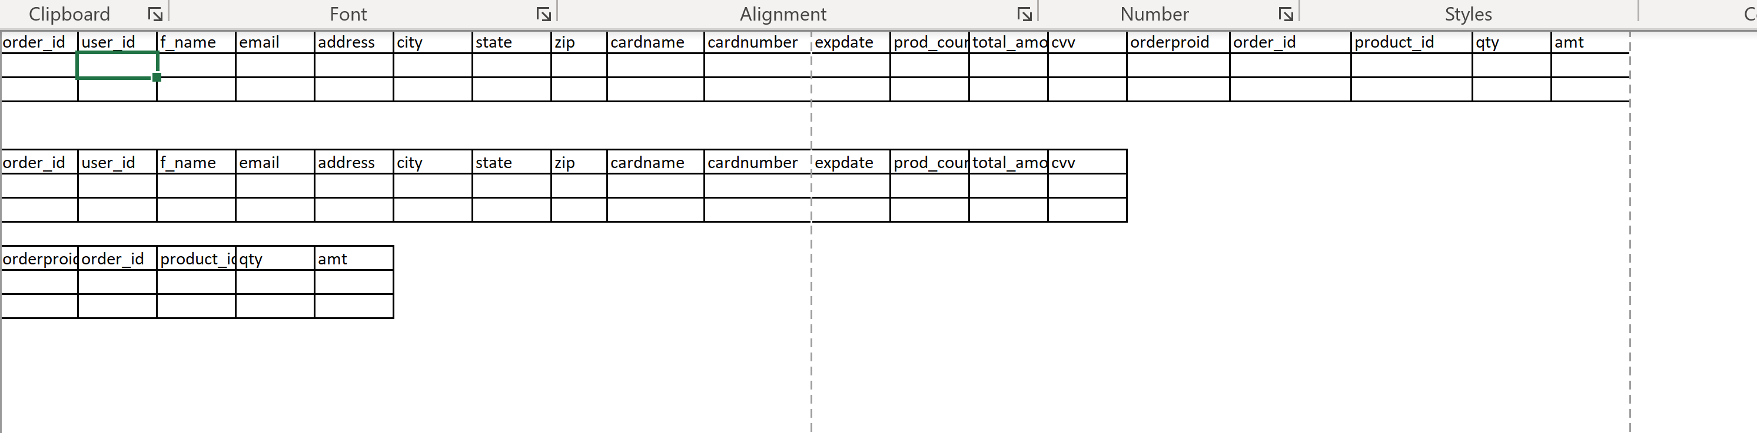

ER Diagram:  
  
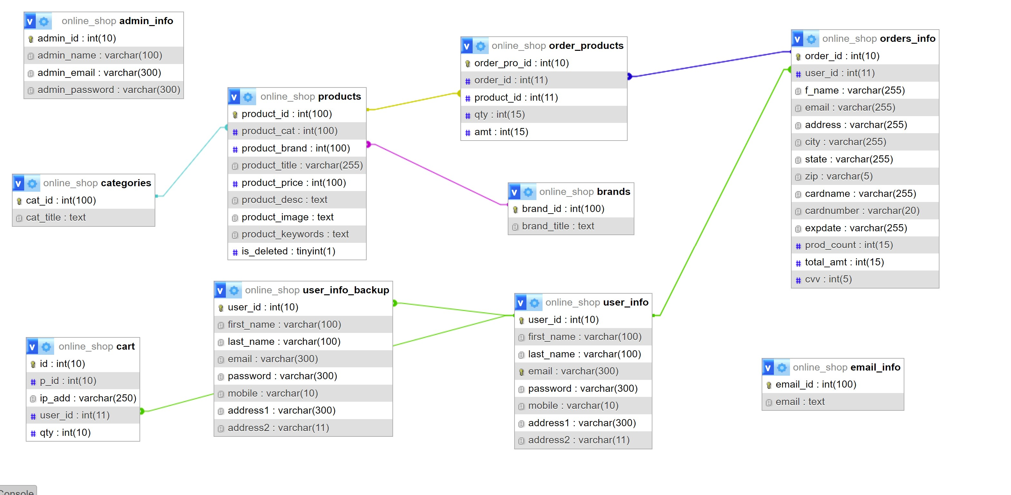

Entities in the Project: User, Mobile Phones , Cart, Admin

Website Flow:  
  
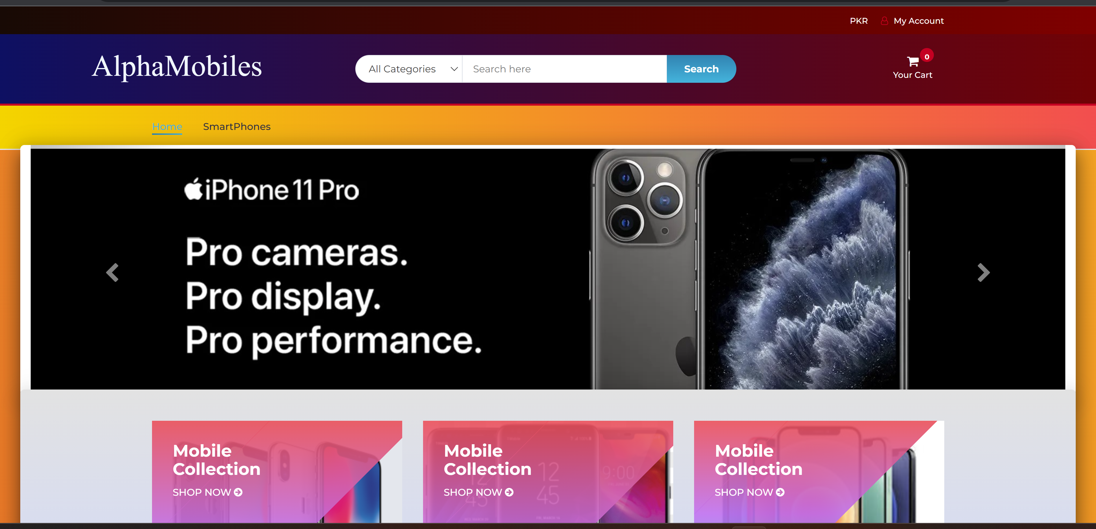

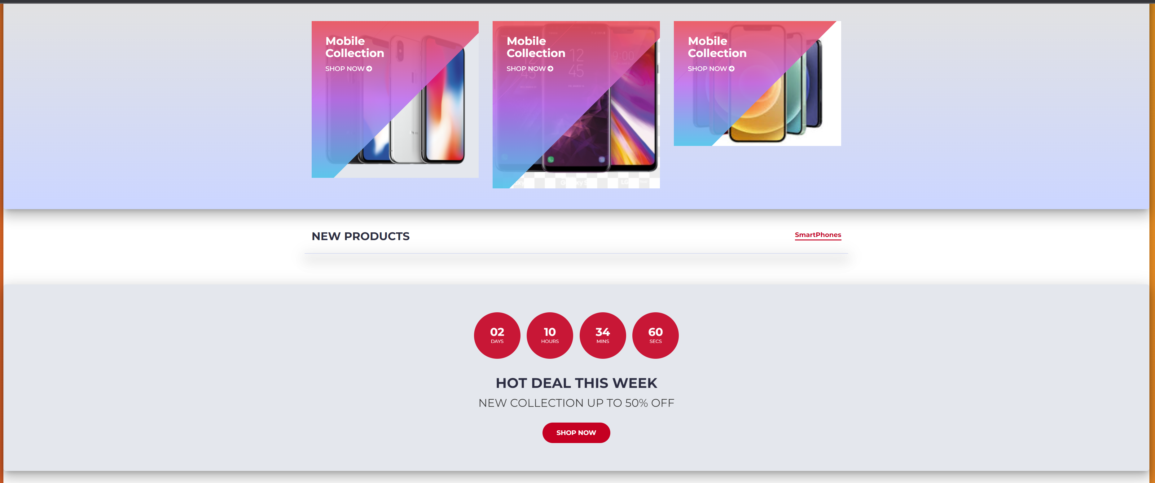

User can browse by clicking on any thing

User can view product list

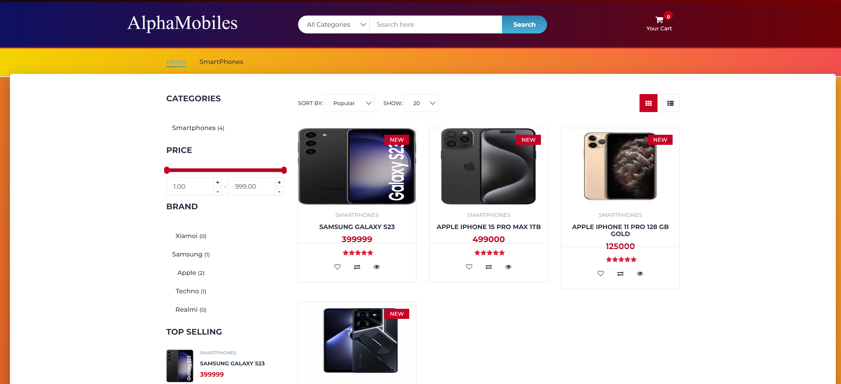

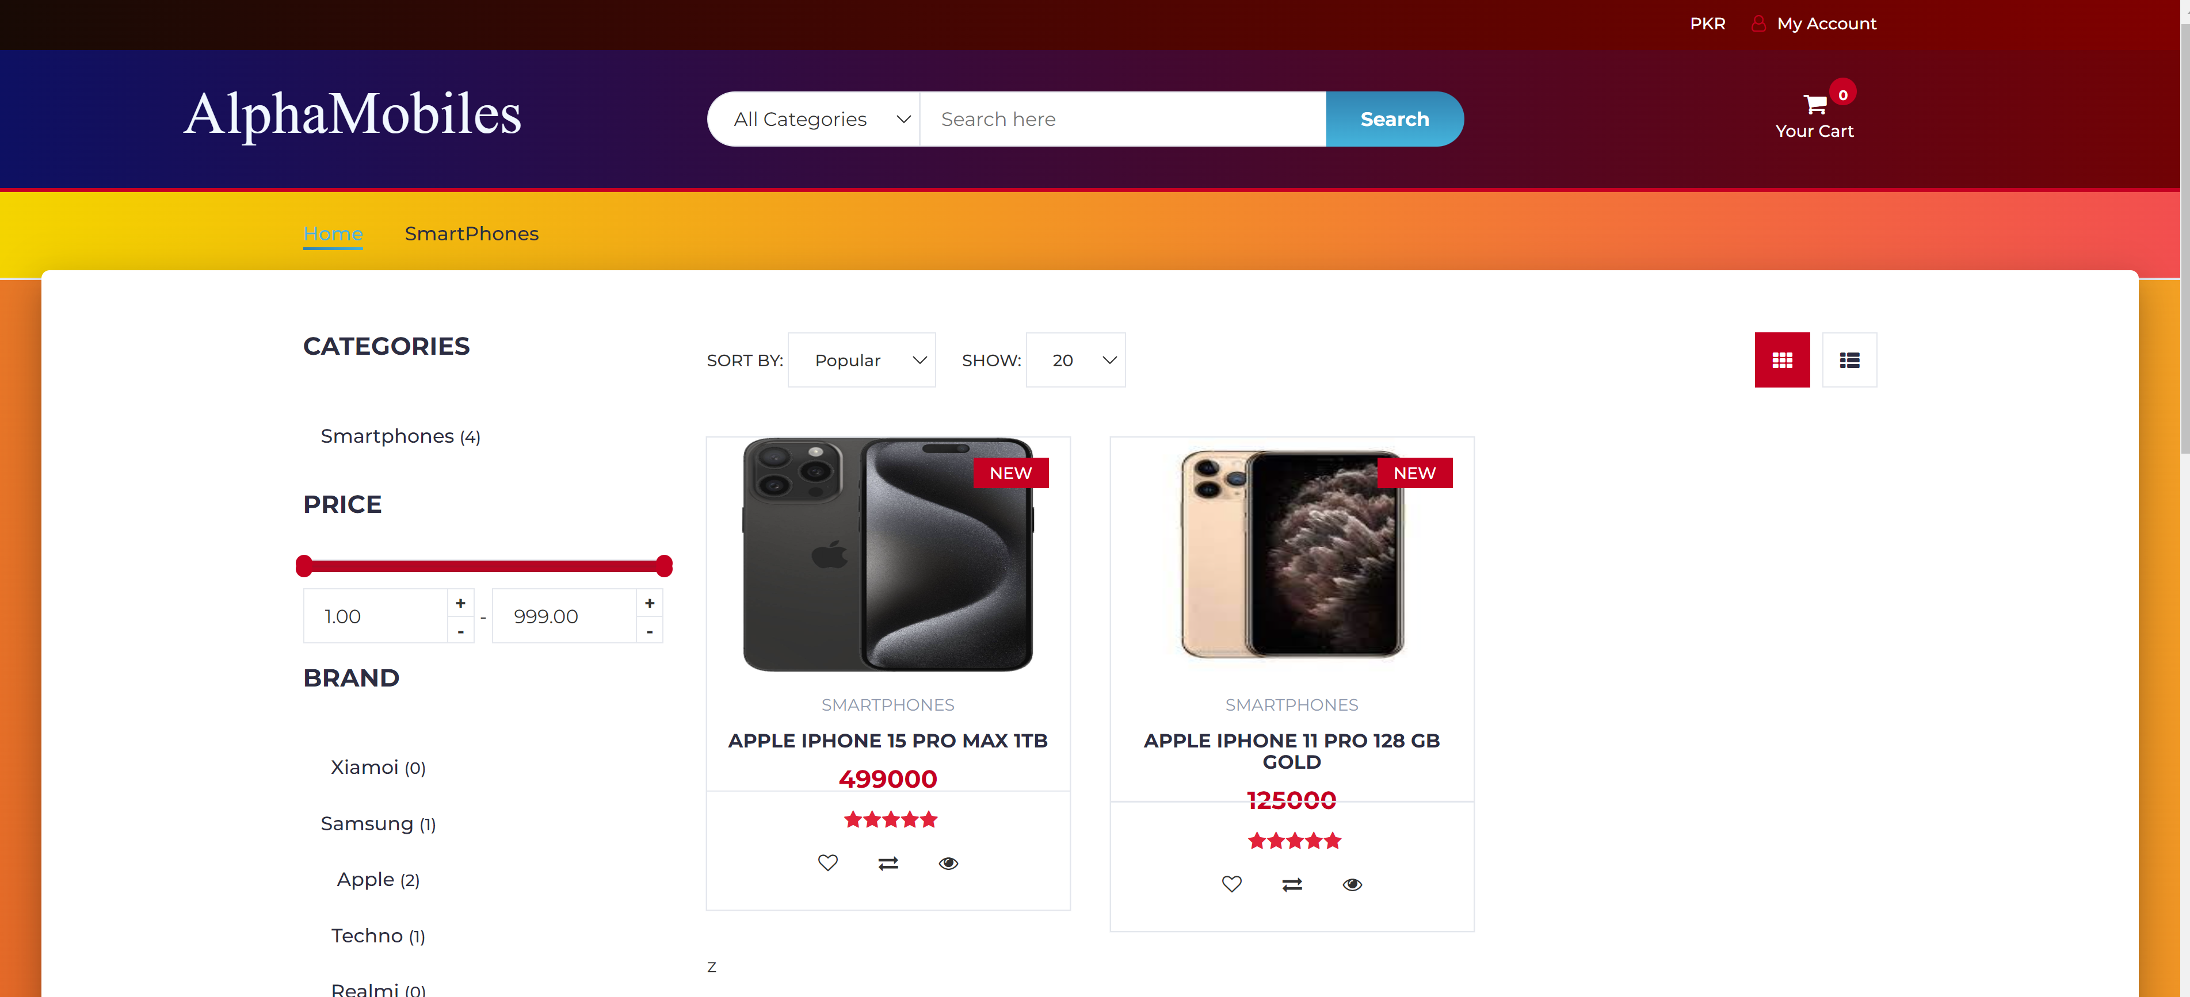

Can also view on the basis of brands

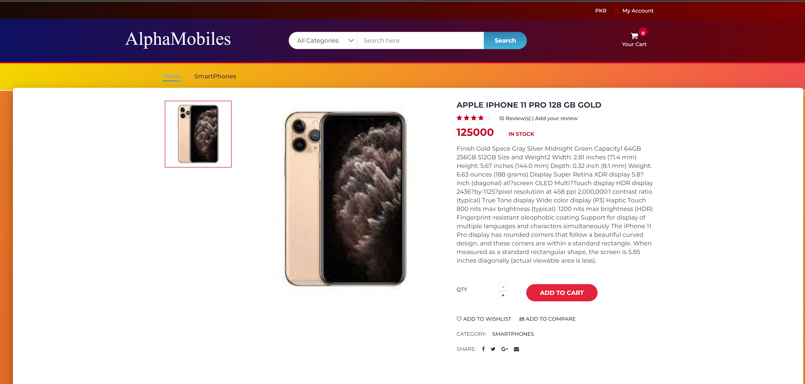

Product details page

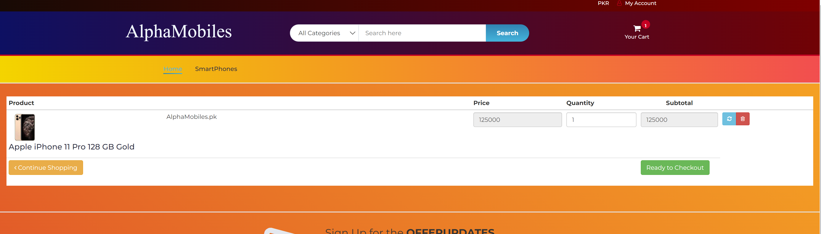

can be added in cart and can edit the cart anytime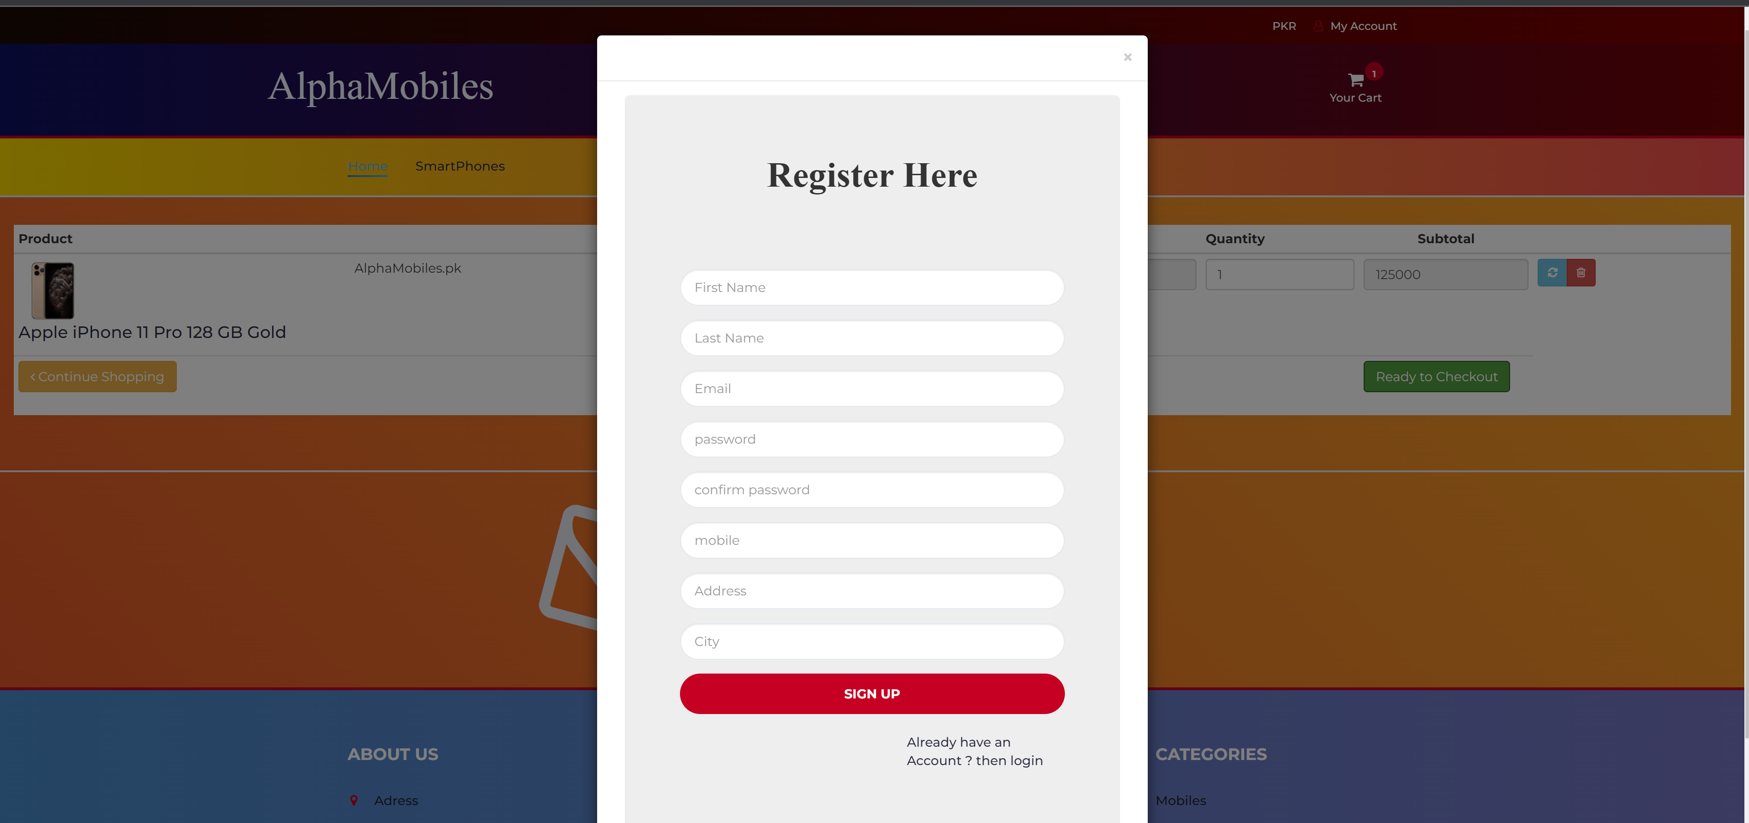 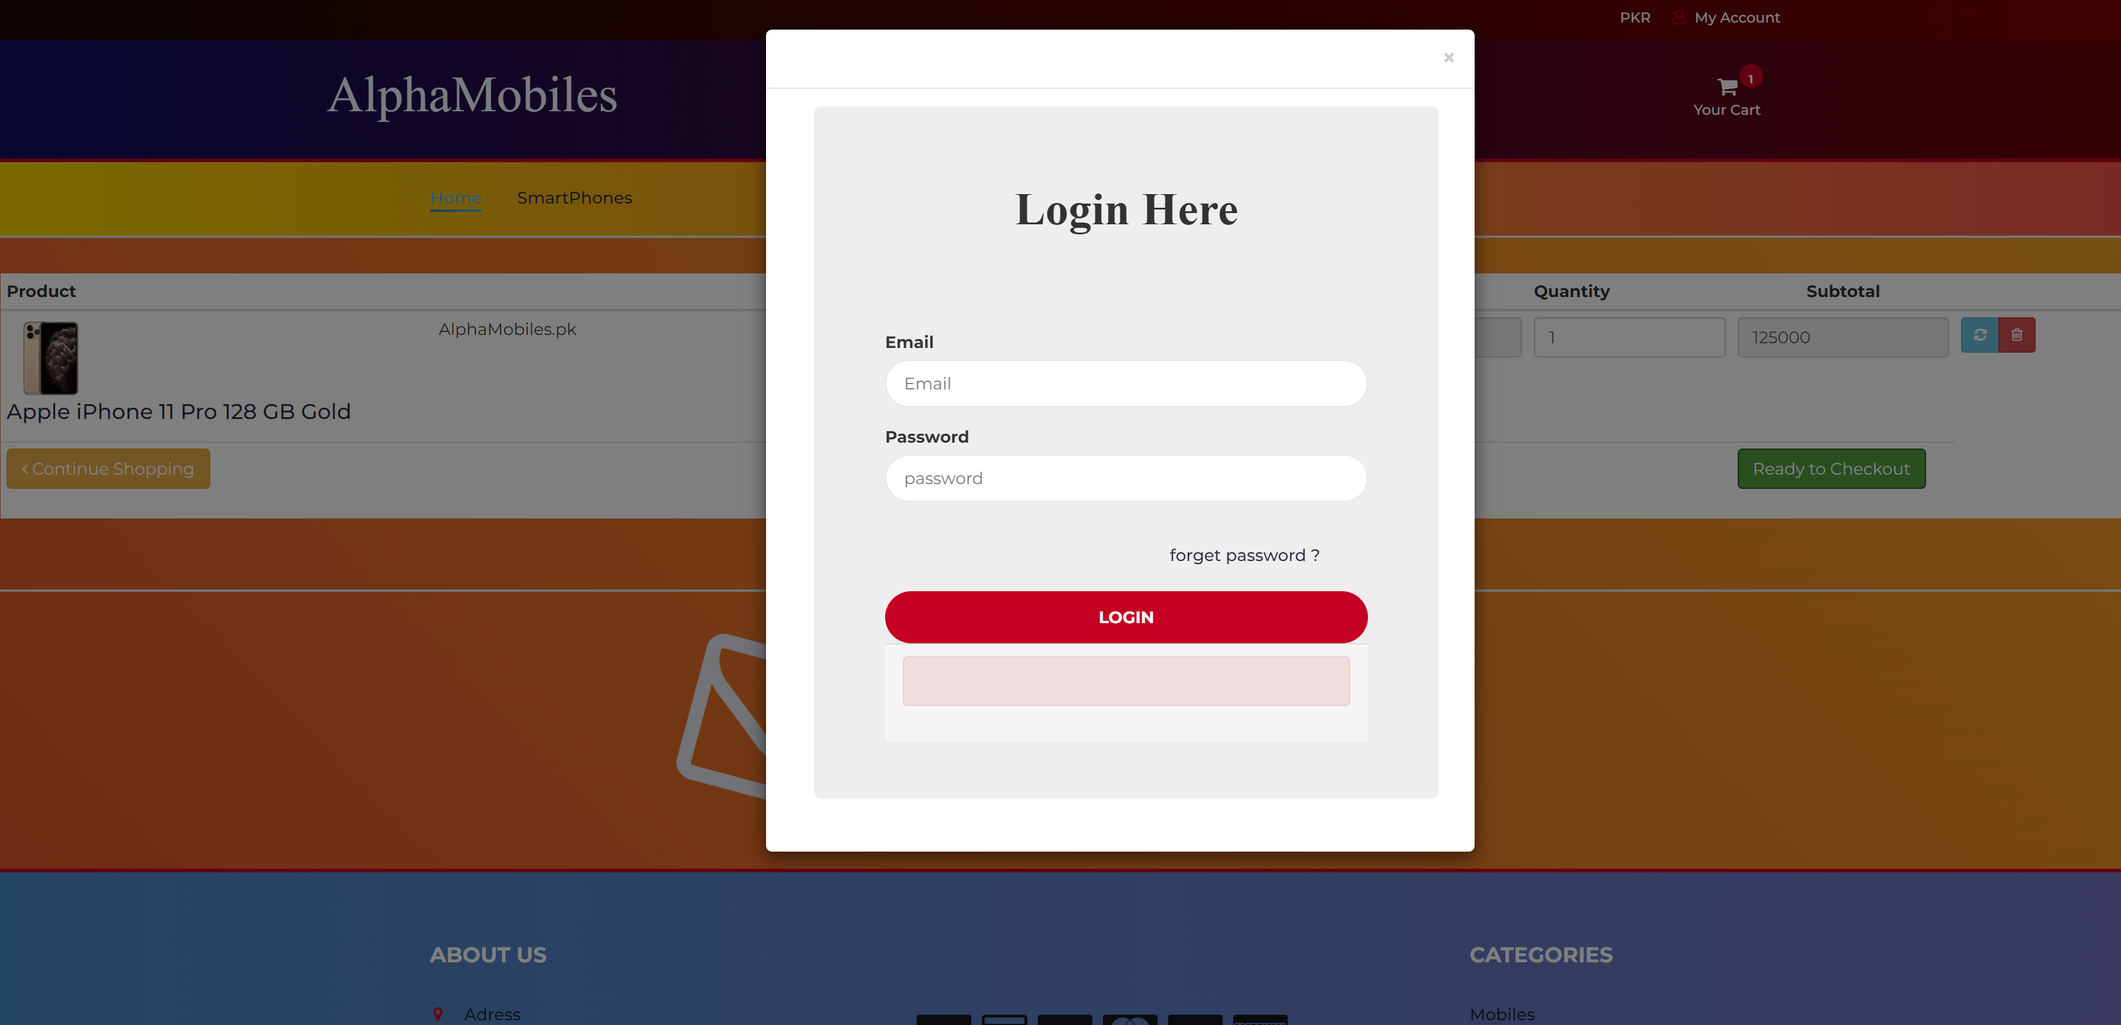

Can only procced further after being logged in

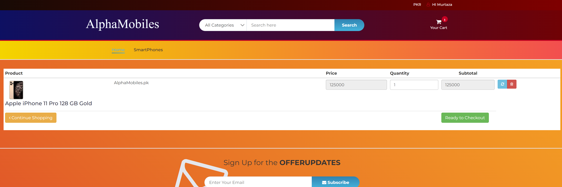

User logged in

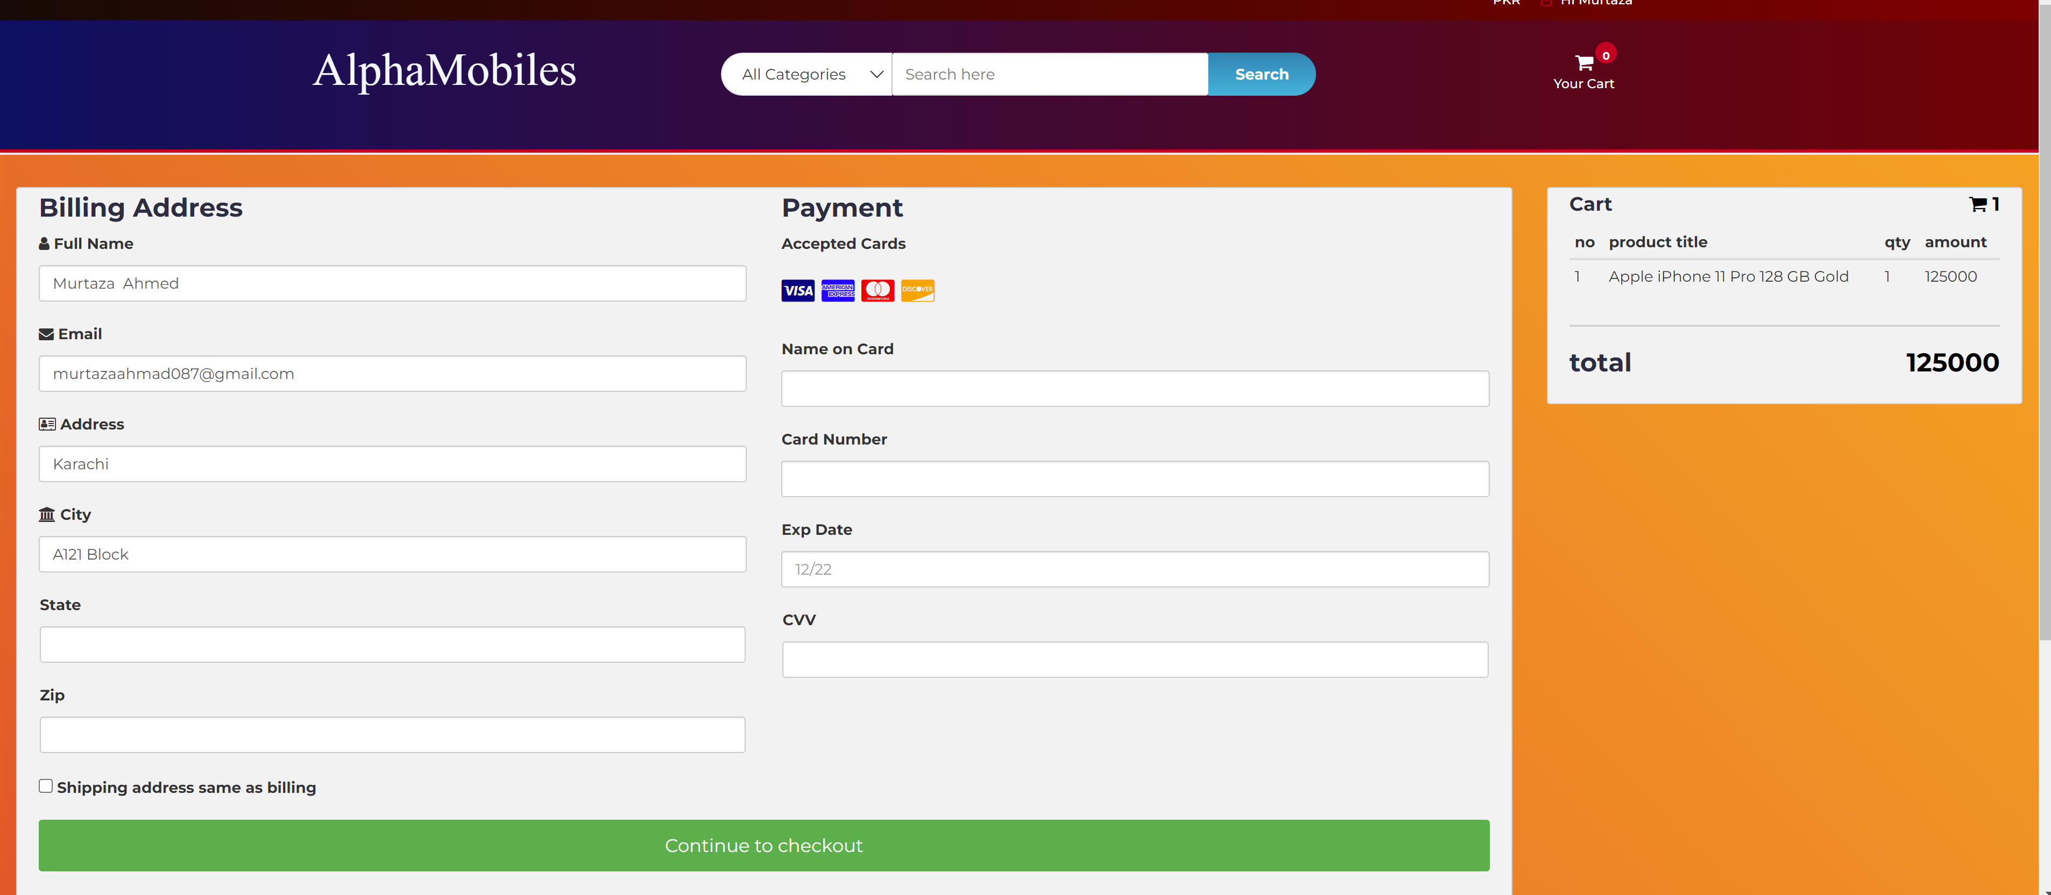

Enter shipping and payment details

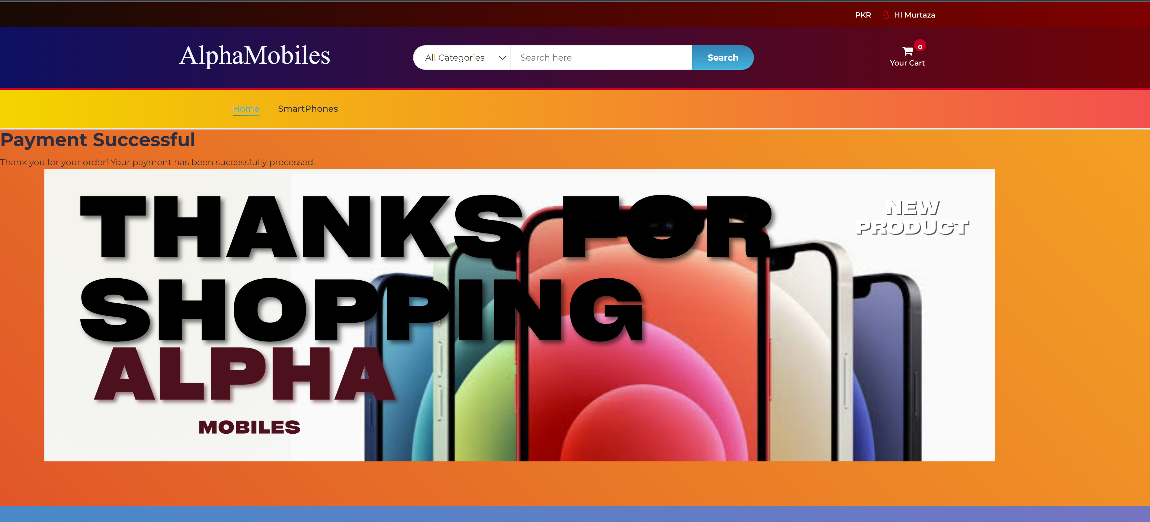

Payment Succesful Order done.

**Admin Panel**

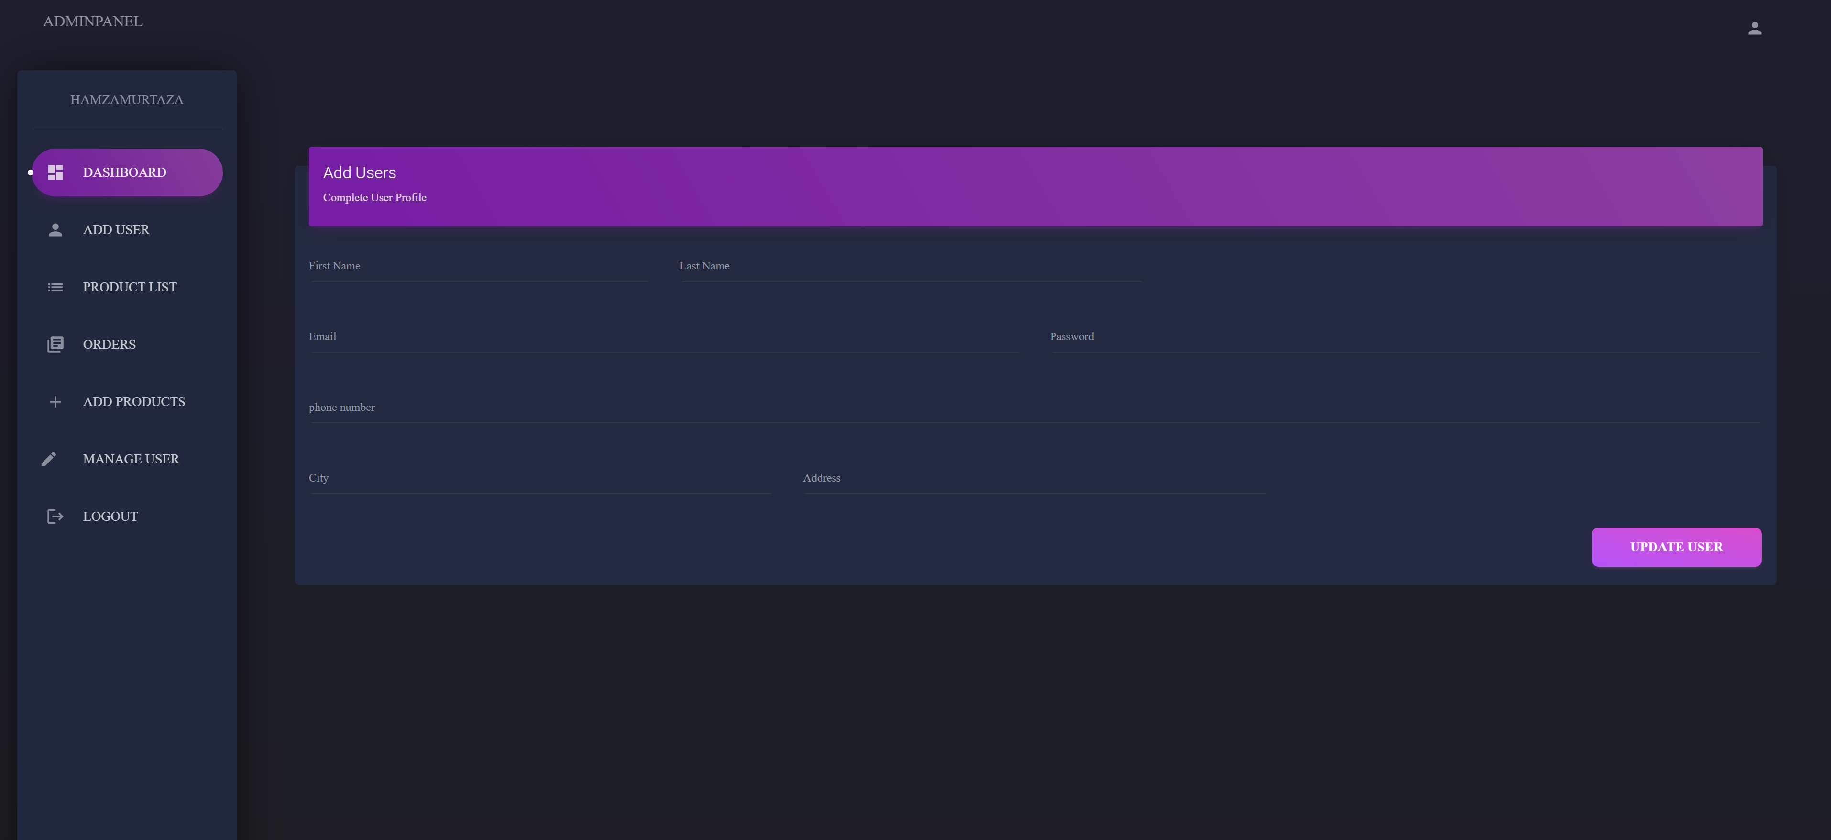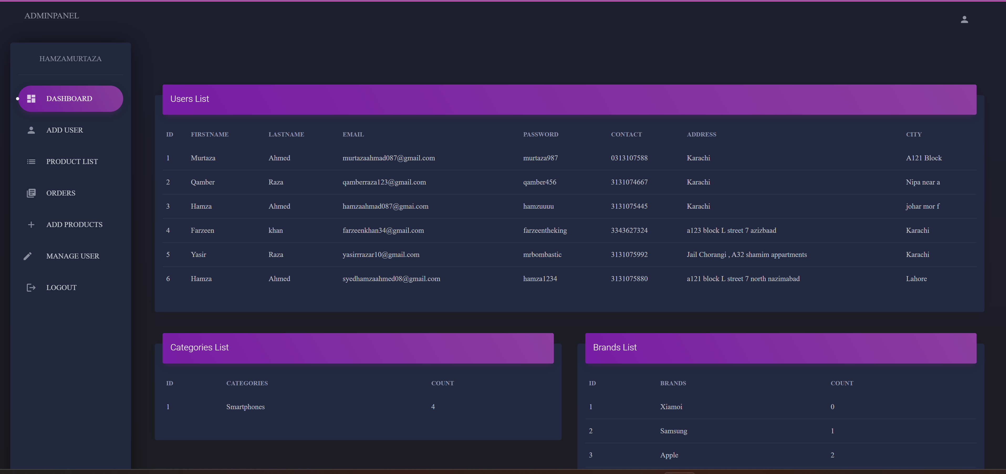

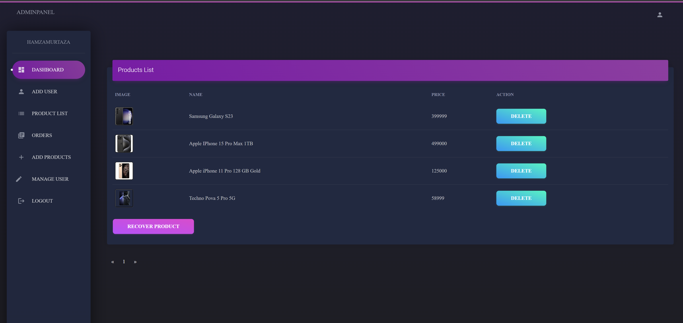

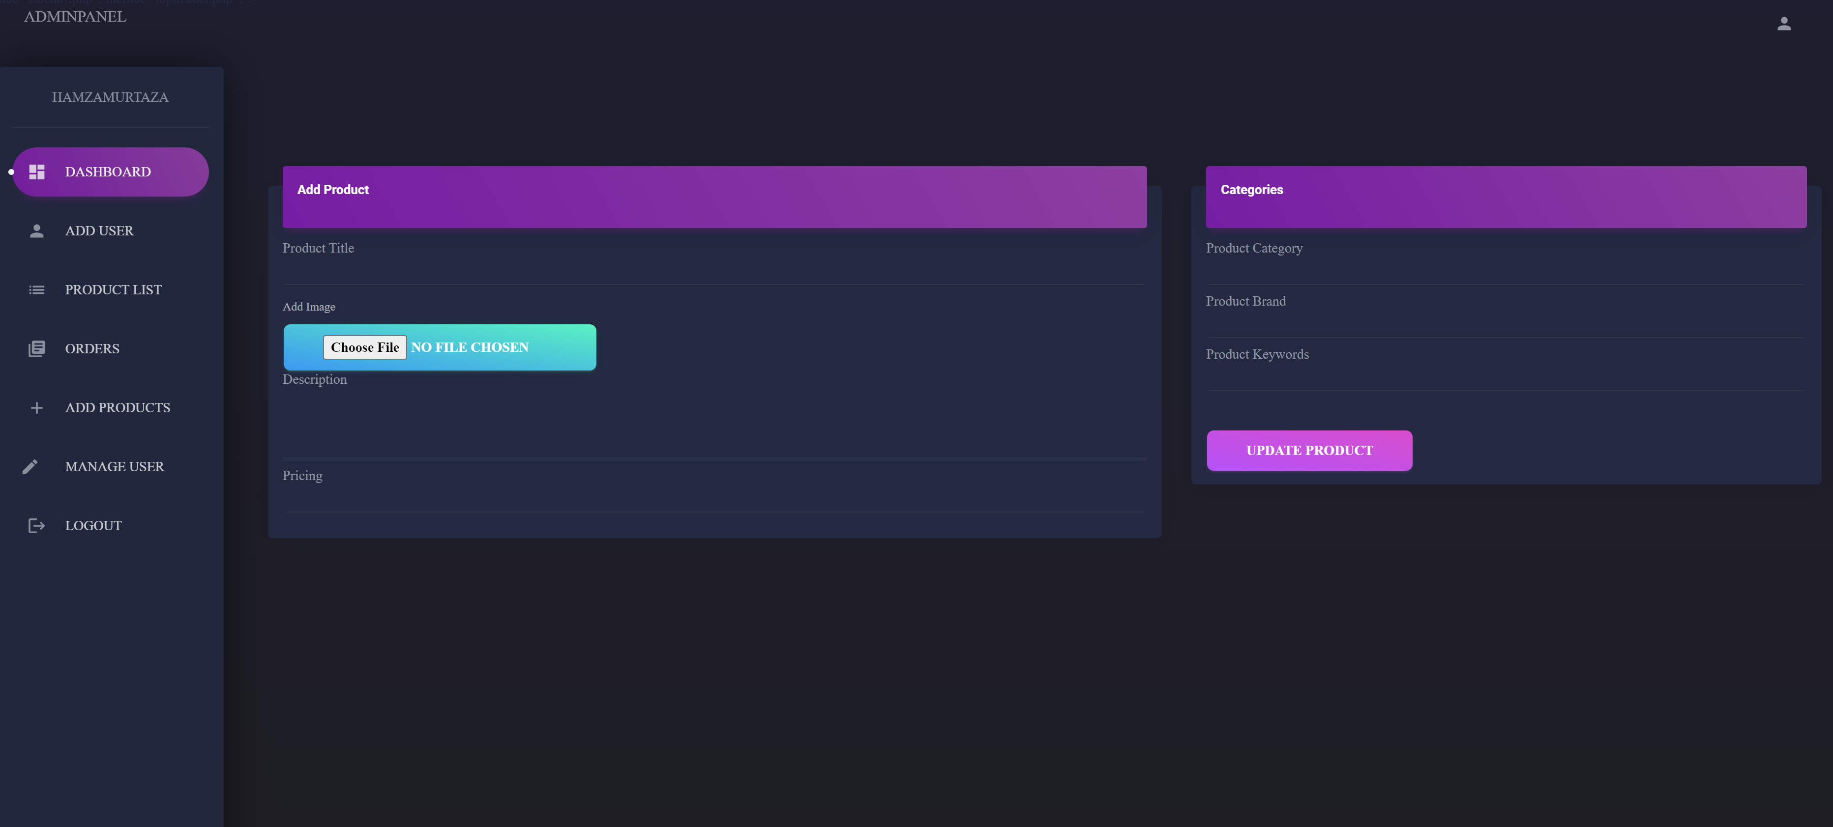

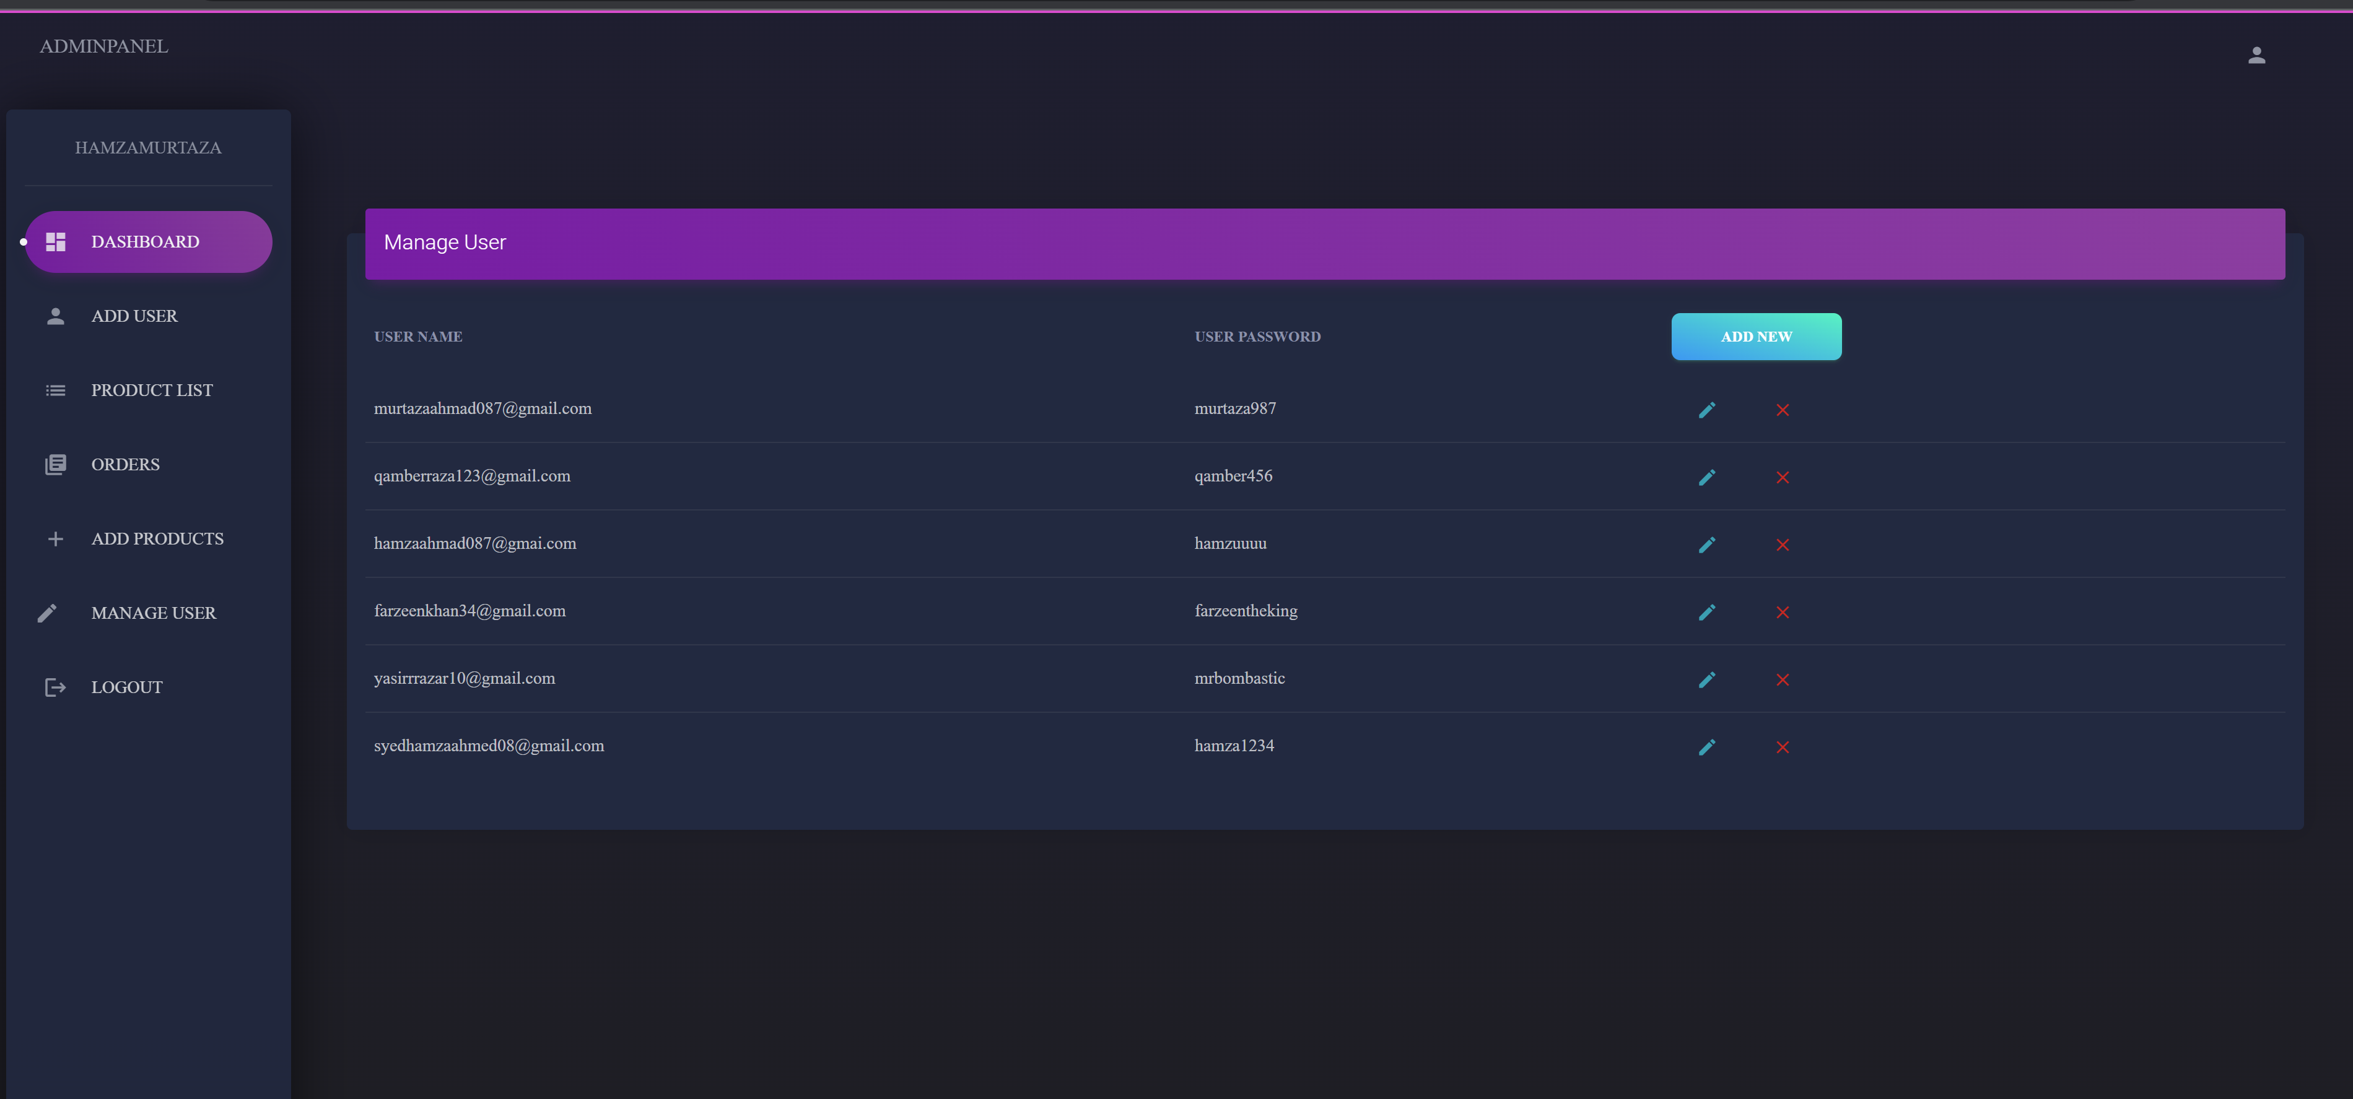

**Functionalities of Admin**

Implementation Phase:  
Use of Triggers:

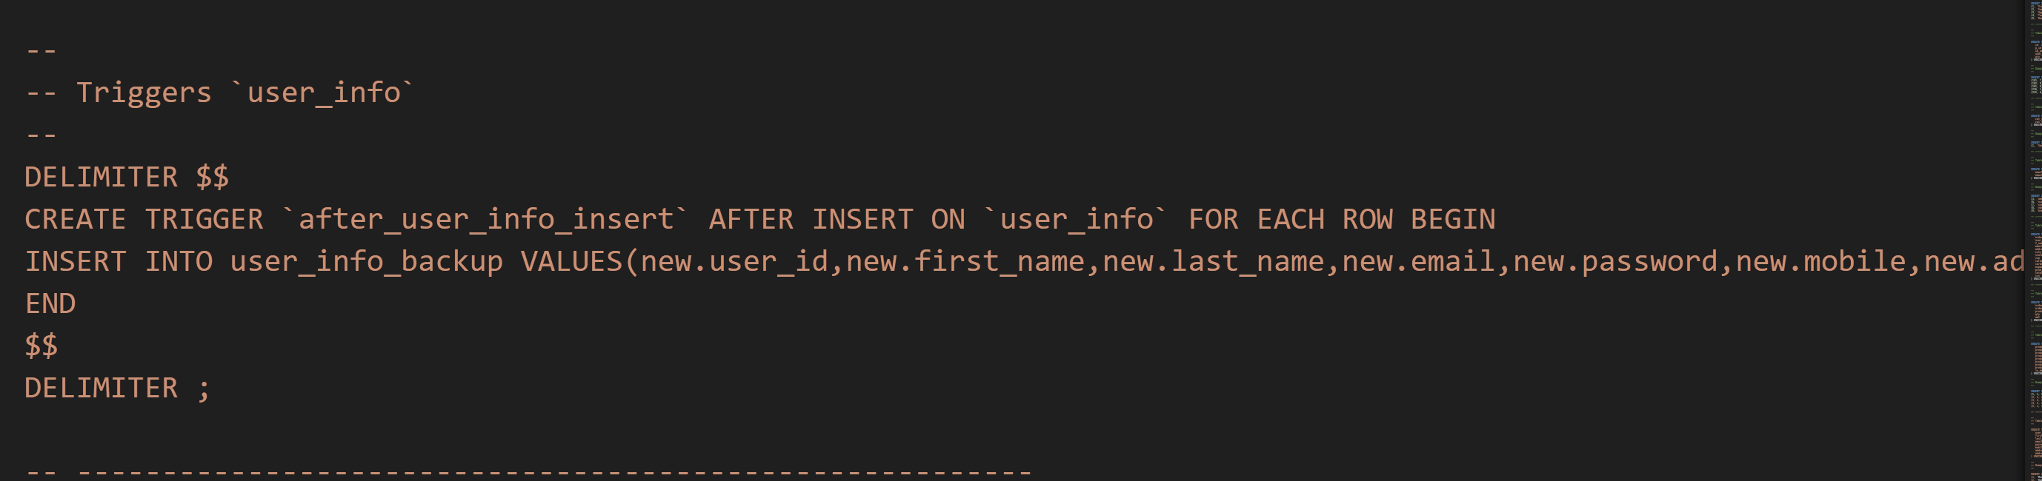

**Transactions Handling while using delete and recover product**

**Other Concepts of database includes:**   
Use of Subqueries, Use of having function, use of group by and use of order by  
  
**Use of other built in functions used include:**Count, Sum, Average, Round, Maximum and Minimum